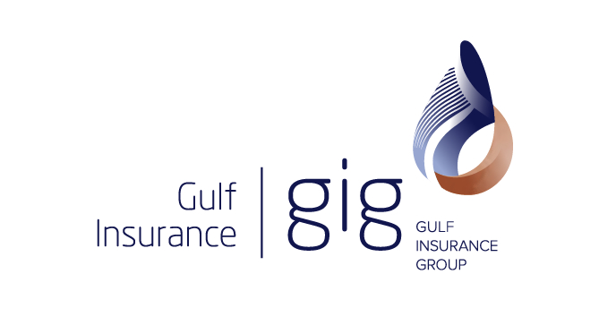

Gulf Insurance announces KD 4.9 million (US$ 17 million) net profit for the first half of 2013 with EPS fils 26.5 per share with book value of 391.3 fils.

Kuwait, July 31,2013- Gulf Insurance Company has announced a net profit of KD 4.9 million (US$ 17 million), or 26.5 fils per share (9.3 cents), for the financial period ended June 30,2013 with an increase of 7.8 percent compared with KD 4.5 million (US$ 15.6 million) or 24.5 fils (8.5 cents) for the same period last year.

The book value of the share at the end of the first half reached 391.3 fils and shareholder’s equity reached KD 71.7 million ( US$ 251.6 million) as of June 30,2013 after a Cash dividends distributed at 25 percent (25 fils per share) amounted KD 4.6 million (US$ 16 million).

The results are marked regardless of the financial and political turmoil in the region. Gulf Insurance was able to achieve evident growth in net profit and technical reserves.

The Gross written premiums has also reached KD 72.9 million (US$ 255.6 million) with an increase of 6.9 percent from last year. The total revenue of the company has reached KD 47.8 million (US$ 167.7 million) with the comparison of last year’s KD 42.3 million (US$ 148.6 million) which brings it to a 12.8 percent increase.

GIC’s net technical reserves have been increased from KD 88.2 million (US$ 309 million) in December 31, 2012 to KD 94.7 million (US$ 332 million) in June 30,2013. This increase represents a 7.4 percent rise and is in the interest of supporting the company’s operational activities and to protect the policy holders rights, thereby strengthening GIC’s ability to sustain emergencies and risks that may rise in the future.

There was an increase in net cash & investments of 3 percent which is equivalent to KD 4.4 million (US$ 15.6 million) which brings it up to KD 151.8 million (US$ 532.5 million) in the end of the 1st half of 2013 in comparison with the KD 147.4 million (US$ 517 million) as of December 31, 2012.

Mr. Khaled Al Hassan, Gulf Insurance’s CEO & MD, said:
“Our results for the 1st half of 2013 reflect the growth we have achieved. This is also a strong indication of the company’s ability to protect its assets and the equity of its shareholders. It also falls in line with our constant strive to provide the best insurance services to our clients in all markets in which we have Presence, supported by our strategy for regional expansion and increasing our local and regional market stake.”
He added:
“We have our clients to thank for these achievements, as well as the support of our shareholders, especially KIPCO – Kuwait Projects Company (Holding) – and Fairfax Middle East Ltd. I would also like to expression my sincere appreciation to our dedicated employees for their efforts.”

-END-

Notes for Editors:
A brief overview of Gulf Insurance Co:
Gulf Insurance Company is the largest insurance company in Kuwait in terms of written and retained premiums, with operations in both life and non-life insurance. Gulf Insurance has become one of the largest insurance networks in the Middle East and North Africa, with companies in Saudi Arabia, Jordan, Lebanon, Syria, Egypt, Iraq and Bahrain, Emirates and Kuwait. Its reported consolidated assets stand at US$ 1.04 billion as at 31st June, 2013.
KIPCO – Kuwait Projects Company – is Gulf Insurance’s largest shareholder, followed by the Canadian-based Fairfax Financial Holding Ltd.
Gulf Insurance holds a Financial Strength Rating of “A-“ with Stable Outlook from Standard & Poor’s. A.M. Best Europe – Rating Services Limited has also assigned a financial strength rating of A- (Excellent) and issuer credit rating of "A-" to Gulf Insurance with a Stable Outlook.
Gulf Insurance, a subsidiary of Kuwait Projects Company (KIPCO), one of the most prominent insurance companies in the region.
For further information, please contact:
Corporate Communications & Investor Relations Department
Tel: +965 22961825 Fax: +965 22961826
Gulf Insurance Company
Ahmed Al Jaber Street, Sharq
P.O. Box 1040, Safat 13011, Kuwait
Tel: +965 1802080; 22961999 Fax: +965 22961998
Email: contacts@gig.com.kw
Websites: www.gulfinsgroup.com.kw; www.clickgic.com

